COUNTY OF NORTHAMPTON

COURT OF COMMON PLEAS

CRIMINAL DIVISION
669 WASHINGTON STREET
EASTON, PENNSYLVANIA 18042-3637
TELEPHONE: (610) 559-3097
FAX: (610) 252-4391
LEIGH ANN FISHER
CLERK OF COURTS – CRIMINAL
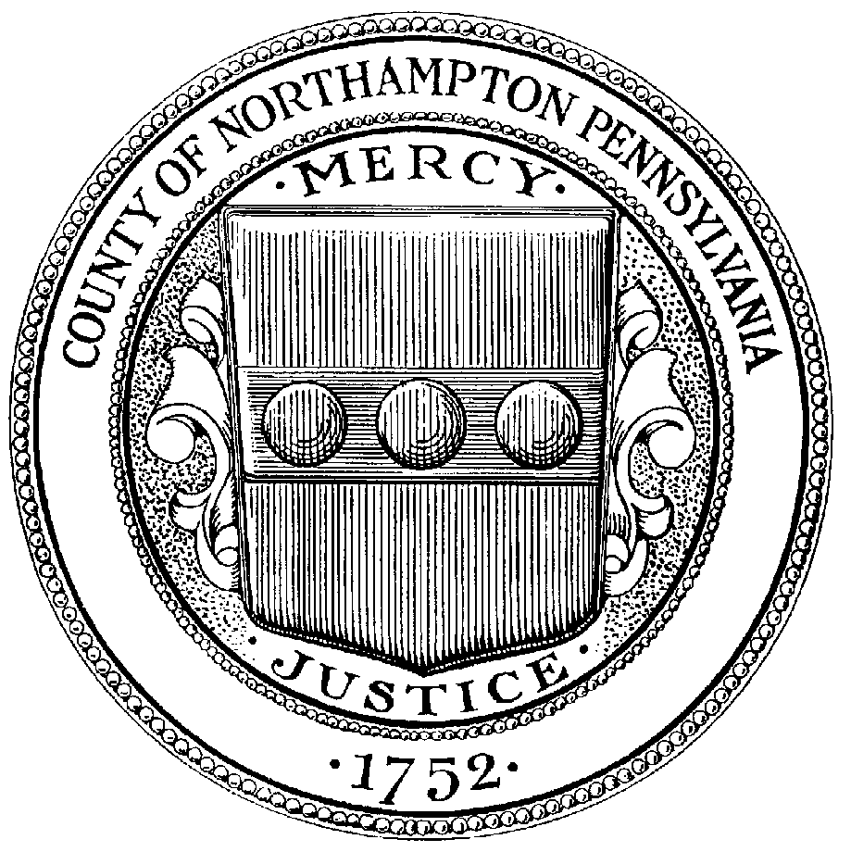

PRAECIPE FOR HEARING LIST

COMMONWEALTH OF PENNSYLVANIA } TERM NO. _________________________
}
VS } _________________________
}
____________________________________________ }

TO THE CLERK OF COURTS-CRIMINAL DIVISION OF NORTHAMPTON COUNTY:

PLACE THE ABOVE CASE ON THE HEARING LIST OF ______________________________

**SUBJECT MATTER: _______________________________________________________________________

__________________________________________________________________________________________

__________________________________ __________________________________ ATTORNEY (Please Print) DISTRICT ATTORNEY (if required)

____________________ __________________________________
ATTORNEY ID # JUDGE (if required)

**NOTE: SUBJECT MATTER MUST BE FILLED IN

