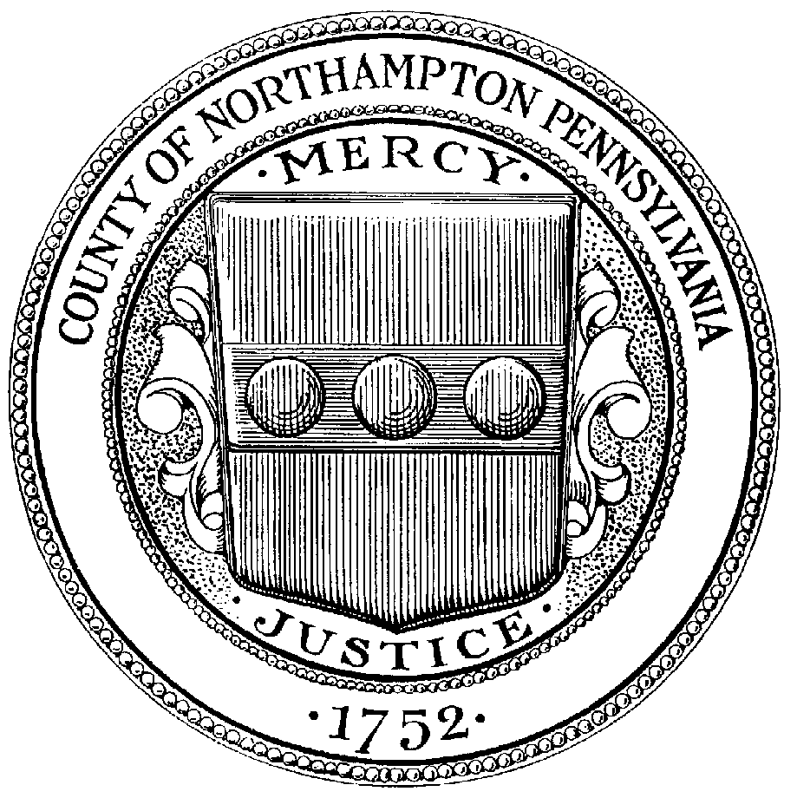

COUNTY OF NORTHAMPTON

CRIMINAL DIVISION
669 WASHINGTON STREET
EASTON, PENNSYLVANIA 18042-3637
TELEPHONE: (610) 559-3208 • FAX: (610) 252-4391

LEIGH ANN FISHER

CLERK OF COURTS – CRIMINAL

CASE # BALANCE
________________ ________________

________________ ________________

________________ ________________

And now this, _____ day of _____________, 20_____, I _______________________________

hereby consent to my employer deducting the sum of $______________ per _______________

_______________________________________ _________________________________
DEFENDANT’S SIGNATURE SOCIAL SECURITY NUMBER

_______________________________________ _________________________________
ADDRESS CITY, STATE, ZIP

( ) - _________________________________
PHONE WITNESS

This money represents payment of fines and court costs and the deduction will remain in full force until all costs, fines, and restitution are paid in full. In accordance with the statutes of the Commonwealth of Pennsylvania, we, the employer of the above defendant, will honor this request. The first deduction will be made on ____________________ and forwarded for proper disposition.

_______________________________________ _________________________________
EMPLOYER’S NAME EMPLOYER’S SIGNATURE

_______________________________________ _________________________________
ADDRESS TITLE

_______________________________________ ( ) -
CITY, STATE, ZIP PHONE

Please make payroll check payable to Criminal Division listing case number and employee’s name and mail to:

Northampton County Government Center
669 Washington Street
Criminal Division
Easton, PA 18042-7494

